FaceComm

**~V3**



**Presented By**

**-Venkata Vamsi Krishna Bhuvanam (ID: 7)**

**-Jebreel M Khurmi(ID: 36)**

**-Sowmya Yelmati(ID: 70)**

**-Sravanthi Dama(ID: 13)**

|  |  |
| --- | --- |
| Authored v1 | Krishna, Sowmya, Sravanthi, Jebreel |
| Authored v2 | Krishna, Sowmya, Sravanthi, Jebreel |
| Authored v3 | Krishna, Sowmya |
| Review 1 | Krishna |
| Review 2 | Krishna |
| Review 3 | Sowmya,Krishna |
| Review 4 | Krishna,Sowmya |

**Version 4:**

1. Multiple Face Detection
2. Multiple Face Cropping
3. Face Matching
4. Calling Feature
5. Messaging Feature

**Version 3:**

1) Face Detection

2) Face Focal Point Detection API implementation

3) Image Cropping

**Version 2:**

1) Importing Contacts

2) Creating Contact

3) Retrieving Contact and Update

4) Login Page using Mongo DB Connections

5) Registration Page using Mongo DB Connections

6) Admin Page using Mongo DB Connections

7) Change Password using Mongo DB Connections

**Version 1:**

1) Analyze the Requirements.

2) Design of application using UML Diagrams, Wire Frames and Mockups

3) Project Plan

4) Framework Specification

Table of Contents

Introduction: 5

Stories/Features: 5

Possible Implementations: 5

Project Goal & Objectives: 6

Goal: 6

Objectives: 6

Project Background: 7

Proposed System: 8

Requirement Specification: 8

Functional: 8

Technical Requirements: 9

Minimum Requirements: 9

Business Process/WorkFlow Analysis: 10

System Specification: 11

Existing Services: 11

New Services (to be built): 11

Project Plan (1st Increment): 12

Kanban/SCRUM Task Scheduling: 12

Stories/Features: 12

Timelines: 14

Members: 14

Task Responsibility: 14

Increments & Goals: 15

1st Increment: 15

2nd Increment: 15

3rd Increment: 15

4th Increment: 15

First Increment Report: 16

Use Case Diagram 16

Class diagram 18

Activity diagram 20

Sequence diagram 21

WireFrames: 22

Mockups: 36

Application Screenshots: 40

Performance Testing: 79

Tools Used: 79

1) YSlow 79

2) Chrome 79

3) Ionic Framework 79

4) NodeJS IO 79

Screenshots: 80

A/B Testing: 84

Unit Test Cases: 86

Screenshots: 86

# Introduction:

An application which will call the person by clicking the face of an image in gallery. No more going back to dialer/caller/phone option and search for contact.

## Stories/Features:

1. This application can be installed in android phone as a normal gallery application (like Google Gallery) and browse the photos taken or downloaded in the phone.
2. The moment the person browsing saw a picture and want to call that particular person in the picture, simply he can tap on the face/photo of that person and wait for the options.
3. Using image recognition, the application will identify the face of the person and will search in the contacts profile picture (image recognition takes place here) and will place a call for the user.
4. If the photo is not matched with any contact, then there might be two possibilities :
5. The Contact which the user is trying to call might not be having any profile pic.
6. Action: Then user will be provided with the options of selecting a contact to assign the picture
7. Result:  Portrait from the picture will be cropped and will be assigned to the contact
8. The image is not mapped to the contact which is already having the profile pic. User can assign the picture to the contact as backup picture
9. In future if the image is not mapped with the profile pic then it will check with the backup pictures which the application has. Based on that it will call the person

## Possible Implementations:

We can add messaging option as well which will send message through another message app or WhatsApp etc.

Mailing to the contact based on Email in contact list.

Scheduling appointments and meetings.

# Project Goal & Objectives:

## Goal:

To enable the user to access the all kinds of applications under one roof.

## Objectives:

Traditionally when user remembered something while browsing through pictures, he have to come out of gallery and then he have to search in contact list and make call or go to messaging app and message the contact. This process will require lot of space in RAM and when he comes back to gallery then he have to start his search once again to go to previous state, which can be avoidable through this application. Usually when a user is searching through his gallery, the moment he want to call him or message about any funny moment to share with him, he can tap on the face on image which will recognize and get the mobile number by searching in contact list. Then user can select the feature like calling or messaging the contact.

## Project Background:

Traditionally when user remembered something while browsing through pictures, he have to come out of gallery and then he have to search in contact list and make call or go to messaging app and message the contact. This process will require lot of space in RAM and when he comes back to gallery then he have to start his search once again to go to previous state, which can be avoidable through this application.

Using this application all features like calling and messaging will be under one roof while browsing through images in gallery.

# Proposed System:

## Requirement Specification:

### Functional:

|  |  |
| --- | --- |
| **FR No.** | **Description** |
| **FR 01** | User should be able to Call the contact by tapping on the face in image which can be browsed through gallery. |
| **FR 02** | User should be able to Message the contact by tapping on the face in image which can be browsed through gallery. |
| **FR 03** | Application should recognize the possible faces in the image. |
| **FR 04** | Application should make call to contact list and fetch the profile pic and should be able to send to a web service which will make a face comparison. |
| **FR 05** | If faces match with profile pic or archive images of contact list user should be able to make call or message to the contact. |
| **FR 06** | If the faces don’t match then the user should be able to search in contact list and select a contact. |
| **FR 07** | If the contact has a profile pic, then it should save the image in archive images of contact list. |
| **FR 08** | If the contact doesn’t have a profile pic, then it should crop the original pic till his face and should assign that picture as profile pic to the contact selected. |

## Technical Requirements:

* 1. Desktop/Laptop with Windows 7 / earlier.
  2. Android SDK/Studio.
  3. Face/Image matching API/Webservice
  4. Android Based Smartphone
  5. Ionic Frame work
  6. NodeJS IO

## Minimum Requirements:

1. Android Kitkat/earlier.

# Business Process/WorkFlow Analysis:

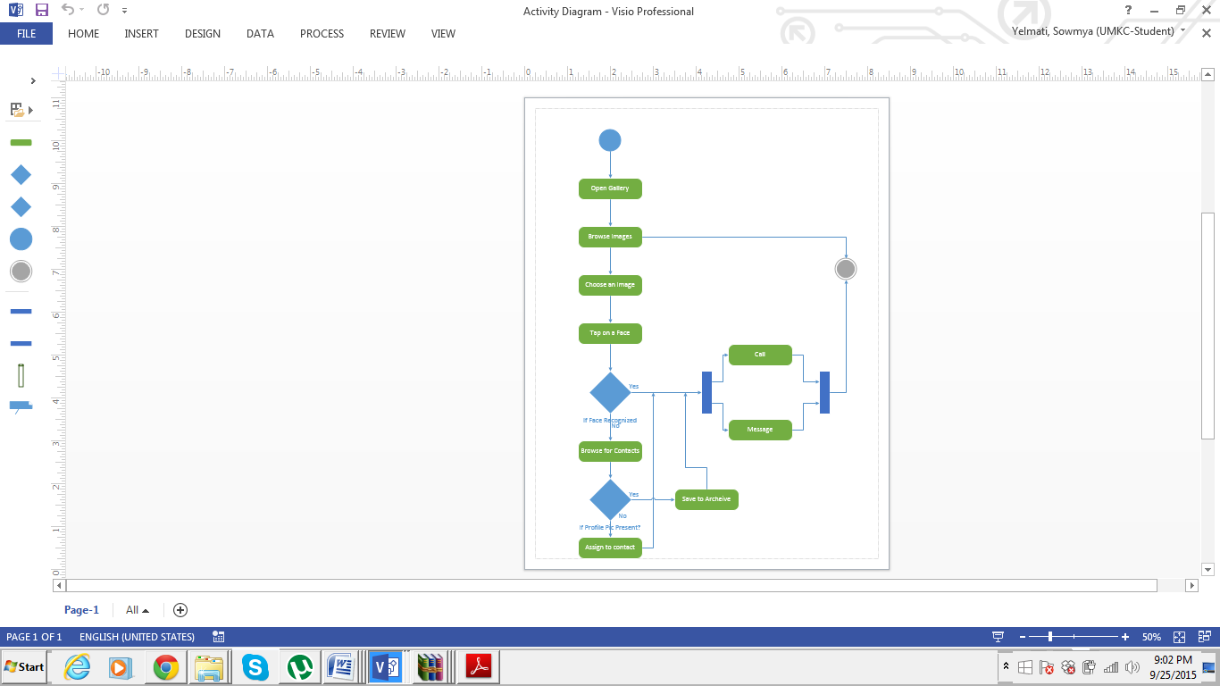

It is an graphical representation of the work flaws of step wise activities. There are many activities involved to use the application .Initially the user open the gallery ,browses the images from all the images present he chooses a particular image taps on a face at the background the face recognization application is run which detects the face with the images assigned if the image is detected then it pop up two options call or message a user can select either of the option. If the image or face is not assigned to any of the contacts list present then it pops an other option to the user saying assign an image to the contact ,the user selects the image and assigns to it an then a call or message service can be selected after using the services we can close the application.

# System Specification:

## Existing Services:

1) Calling Feature: Application should call the existing calling feature in android and should make call to the contact based on image match.

2) Messaging Feature: Application should call the existing messaging feature in android and should message to the contact based on image match.

## New Services (to be built):

1) Application should identify the faces in images from gallery.

2) Application should make a call to web-service for image matching.

# Project Plan (1st Increment):

## Kanban/SCRUM Task Scheduling:

Snapshot:

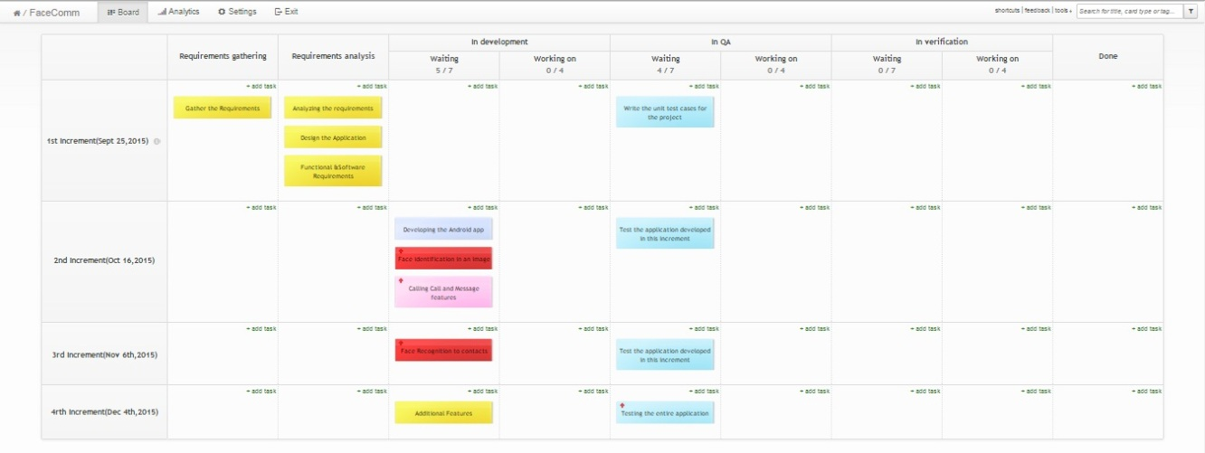

## Stories/Features:

1. This application can be installed in android phone as a normal gallery application (like Google Gallery) and browse the photos taken or downloaded in the phone.
2. The moment the person browsing saw a picture and want to call that particular person in the picture, simply he can tap on the face/photo of that person and wait for the options.
3. Using image recognition, the application will identify the face of the person and will search in the contacts profile picture (image recognition takes place here) and will place a call for the user.
4. If the photo is not matched with any contact, then there might be two possibilities :
5. The Contact which the user is trying to call might not be having any profile pic.
6. Action: Then user will be provided with the options of selecting a contact to assign the picture
7. Result:  Portrait from the picture will be cropped and will be assigned to the contact
8. The image is not mapped to the contact which is already having the profile pic. User can assign the picture to the contact as backup picture
9. In future if the image is not mapped with the profile pic then it will check with the backup pictures which the application has. Based on that it will call the person

### Timelines:

|  |  |
| --- | --- |
| **Increment** | **Date** |
| 1st Increment | Sept 25, 2015 |
| 2nd Increment | Oct 19, 2015 |
| 3rd Increment | Nov 6, 2015 |
| 4th Increment | Dec 4, 2015 |

### Members:

|  |  |  |
| --- | --- | --- |
| **S.no** | **Name** | **Class ID** |
| 1 | Venkata Vamsi Krishna Bhuvanam | 7 |
| 2 | Jebreel M Khurmi | 36 |
| 3 | Sowmya Yelmati | 70 |
| 4 | Sravanthi Dama | 13 |

### Task Responsibility:

|  |  |  |
| --- | --- | --- |
| **S.no** | **Name** | **Task Responsibility** |
| 1 | Venkata Vamsi Krishna Bhuvanam | Documentation, Requirements Gathering, Task Scheduling, Android Framework Architecture, Funcational Testing |
| 2 | Jebreel M Khurmi | Documentation, Functional Testing |
| 3 | Sowmya Yelmati | Task Scheduling, Development, Android Framework Architecture |
| 4 | Sravanthi Dama | Development, Unit Testing |

## Increments & Goals:

### 1st Increment:

1) Analyze the Requirements.

2) Design of application using UML Diagrams, Wire Frames and Mockups

3) Project Plan

4) Framework Specification

### 2nd Increment:

1) Importing Contacts

2) Creating Contact

3) Retrieving Contact and Update

4) Login Page using Mongo DB Connections

5) Registration Page using Mongo DB Connections

6) Admin Page using Mongo DB Connections

7) Change Password using Mongo DB Connections

### 3rd Increment:

1) Android Application Face Identification in an image.

2) Non-Working Model of Face Recognition Calls.

### 4th Increment:

Additional Features

1) Calling Call & Message Features in Android system.

2) Mailing Feature

3) Meeting/Appointment Request.

4) Calendar Updates.

5) Testing.

# First Increment Report:

## Use Case Diagram

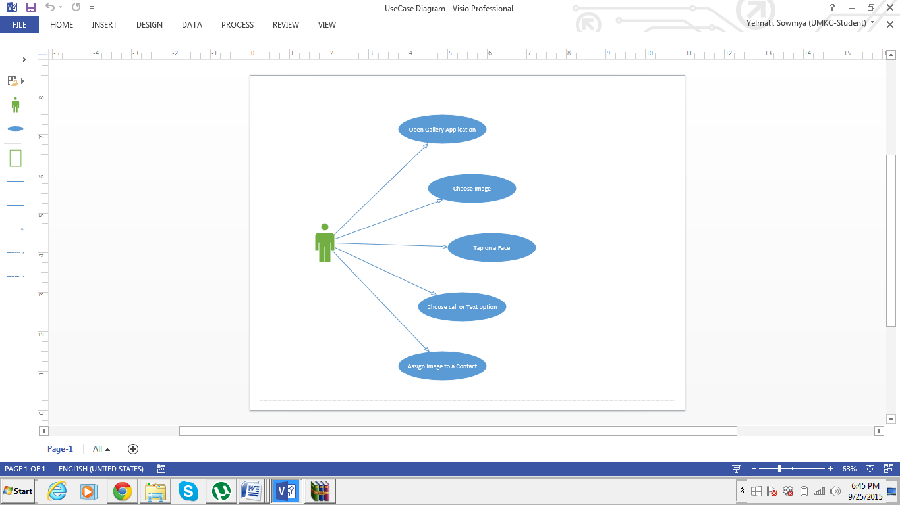

The Use Case diagrams of the project deals with the users interaction with the system that shows the relationship between the user and different use cases in which user is involved. The proposed project involves five use cases .

Open gallery application

First interaction of the user with the system is by choosing or opening the gallery option present among all the apps .

Choose Image

The Second interaction involves choosing an image among all the images present in the gallery

Tap on the face

After choosing an image the user need to select or tap on the face he wish to make a call or message .

Choose call or text option

The face of the selected user is recognized from the assigned contacts picture and the number is displayed which gives an option to call or text. A user may select the desire option.

Assign Image to contact

If the selected face of the user is not present among the images which are assigned to the contacts then the user has an option to assign an image to that contact and save it to the contacts list.

## Class diagram

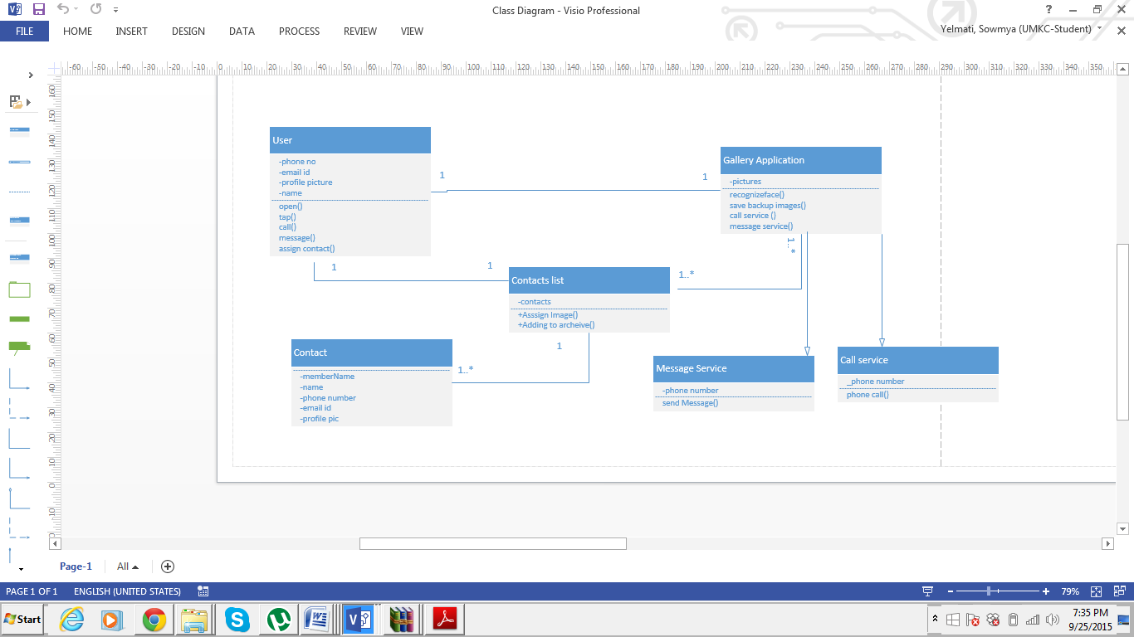

The classes in a class diagram represent both the main objects, interactions in the application and the classes to be programmed. The project FACE COMM has six classes which completely gives the information about the application.

User Class

The attributes of the user class name, phone number, email I d and picture are private which is confined to a particular user hence the visibility feature is enclosed as private. The methods the class can execute are open() which opens the application ,tap() which selects face from a picture, call () which calls the selected face, message() which allows the user send a message to the selected contact ,assigncontact() assigns an image to the contact .

The relationship of the user class is one to one association with gallery application class , contact list ,contact.

Gallery Application

The attributes of the gallery application are images which has a visibility feature of private ,the methods the gallery application class can execute are recognize face () which recognizes the face call service() which provides an option to call message service() which provides an option to message ,save backup images () method includes the process of saving the backup images which are not detected.

The relationship of this class with the other class are association and inheritance .It has an inheritance relation ship with message and call class. One to many association with the contact list class and an one to one association with the use class.

Contact list class

The attribute of this class are contacts which are numeric data type and a visibility of private .The methods the class can execute are assign an image () which assigns an image ,add image to archive() adds the images selected by the user to archive. The relationship of this class with the other class includes association with the gallery application ,contact list and user.

Contact class

The attributes of the Contact class are member name, name ,phone number, email id an profile image the relation ship with the other classes is association with contact list.

Message Service

The attributes of the message service includes the number and the method includes message service () which send a message to the selected person

Call Service

The attributes of the message service includes the number and the method call service() which provide an option to call to the desired contact.

## Activity diagram



It is an graphical representation of the work flaws of step wise activities. There are many activities involved to use the application .Initially the user open the gallery ,browses the images from all the images present he chooses a particular image taps on a face at the background the face recognization application is run which detects the face with the images assigned if the image is detected then it pop up two options call or message a user can select either of the option. If the image or face is not assigned to any of the contacts list present then it pops an other option to the user saying assign an image to the contact ,the user selects the image and assigns to it an then a call or message service can be selected after using the services we can close the application.

## Sequence diagram

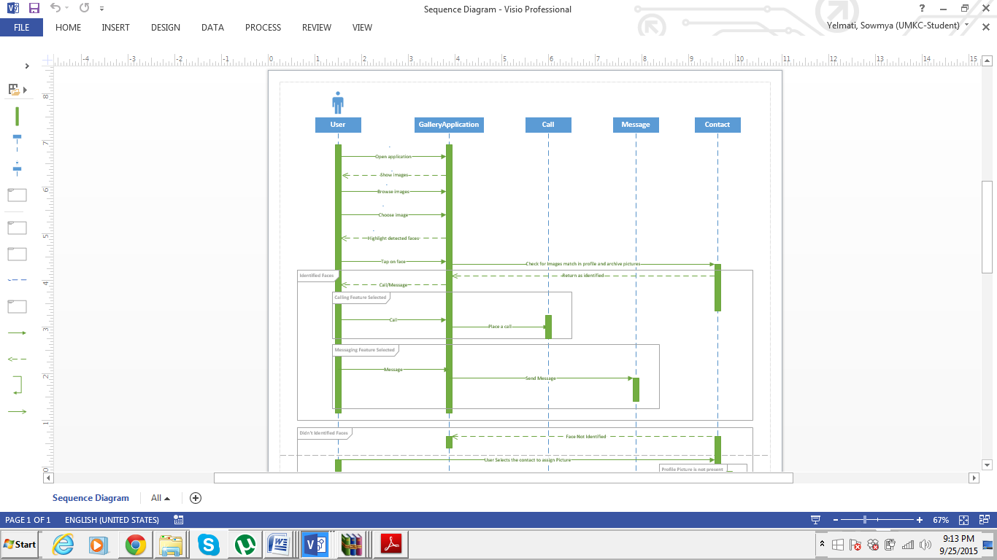

The sequence diagram shows how processes operates with one another and in which order .The operation include opening the gallery application ,browsing the images and selecting a particular image ,taping on the face of the particular person if the face is detected then we have two services of message and call .If the face is not present in the contact list it verifies with the images in the backup if the image is not recognized then it pops up an application to assign an image and save it to the backup. The user selects the option and assigns the image and use the call and message service .

# WireFrames:

The frame above shows the first frame of our project which will appear automatically when you run the facecom application and allow you to browsing gallery that is already installed in your smart device.



The frame above shows the first frame of our project which will show you specific person’s image after you chose specific image from your picture gallery.



This frame shows the third frame of our project which will run and automatically identify the selected image from your gallery with you contact.



The frame above shows the fourth frame of our project which will allow you after tapping on the selected image with two option wither call or message the selected person’s number through the image which you already selected and identified in this app.



The frame above shows the fifth frame of our project which shows the frame after tapping on call option from the fourth frame. This frame gives you different features that are showing above such as end call between you and the selected person, using your pad, choose to talk with him or her via speakers, mute his or her voice, and even you could call someone else and let him or her have a nice conversation with both of you.



The frame above shows the sixth frame of our project which shows the frame after tapping on message. Yeah do not be shuck we could do more!!. This frame gives you many features such as a normal phone message options which include the normal way to text someone using keyboard.



The frame above shows the seventh frame of our project which shows you two options in case the selected image is not recognize. The two options are: Search in Contacts and Close.

Note: those frames might be changed during project processing phases.

# Mockups:

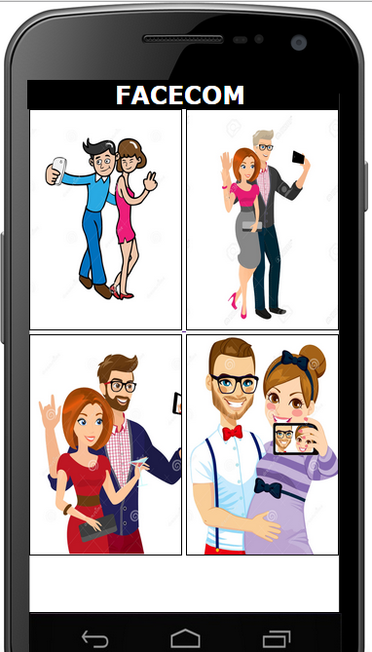

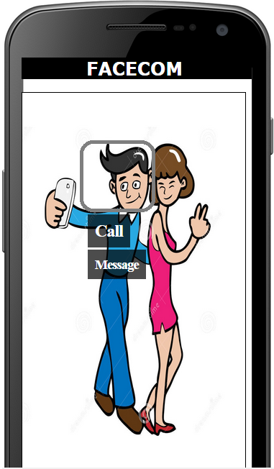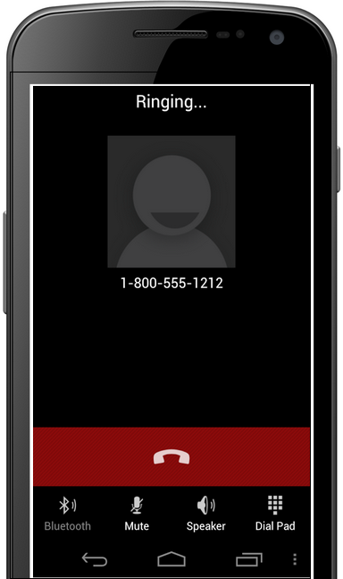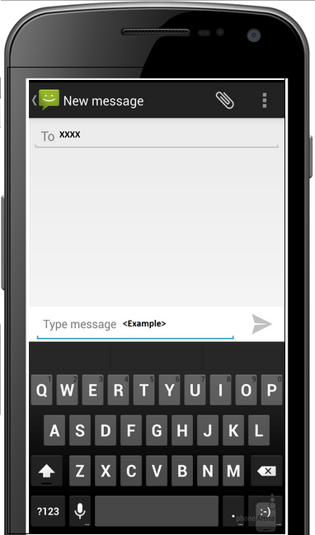

# Application Screenshots:

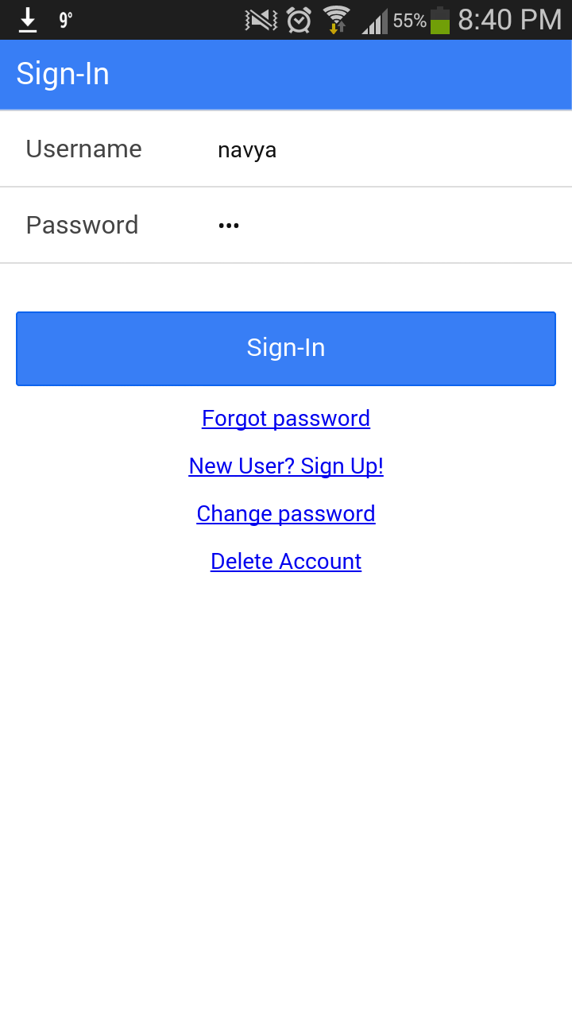

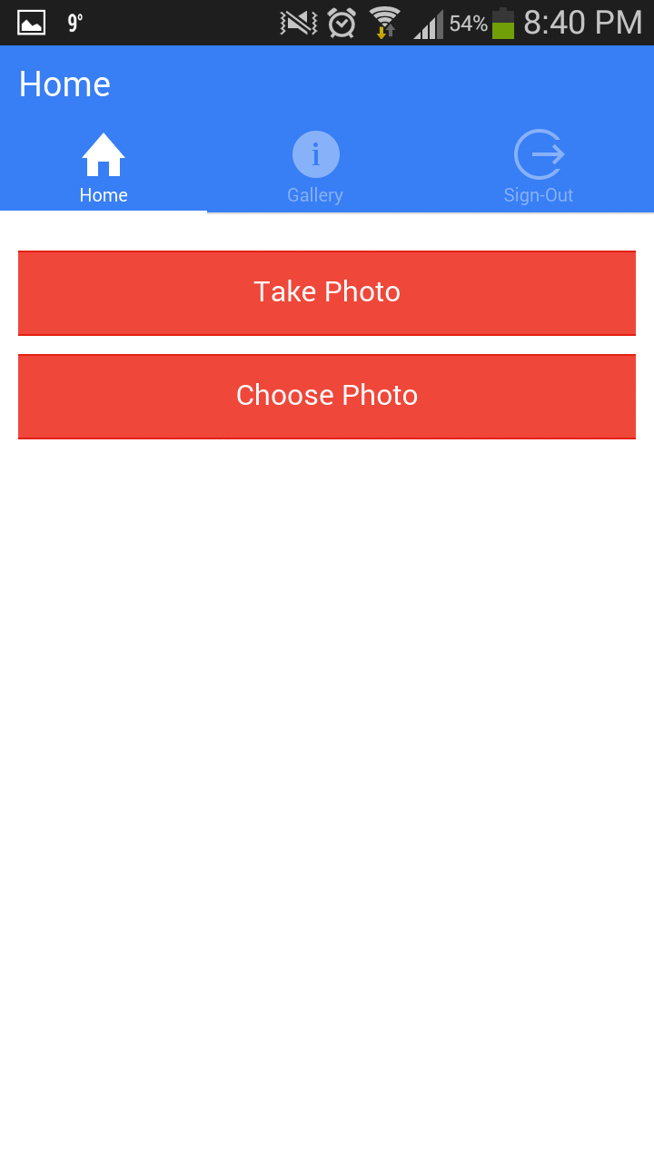

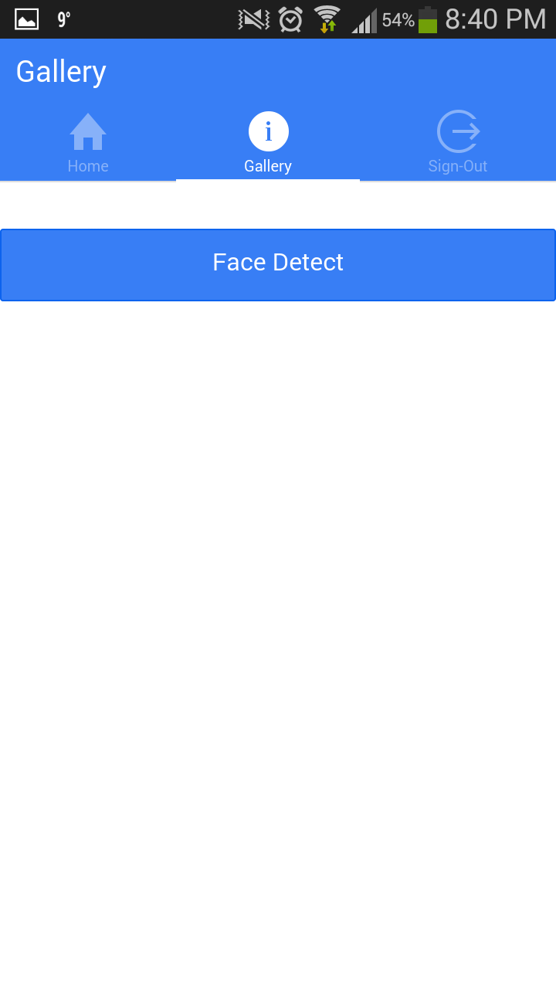

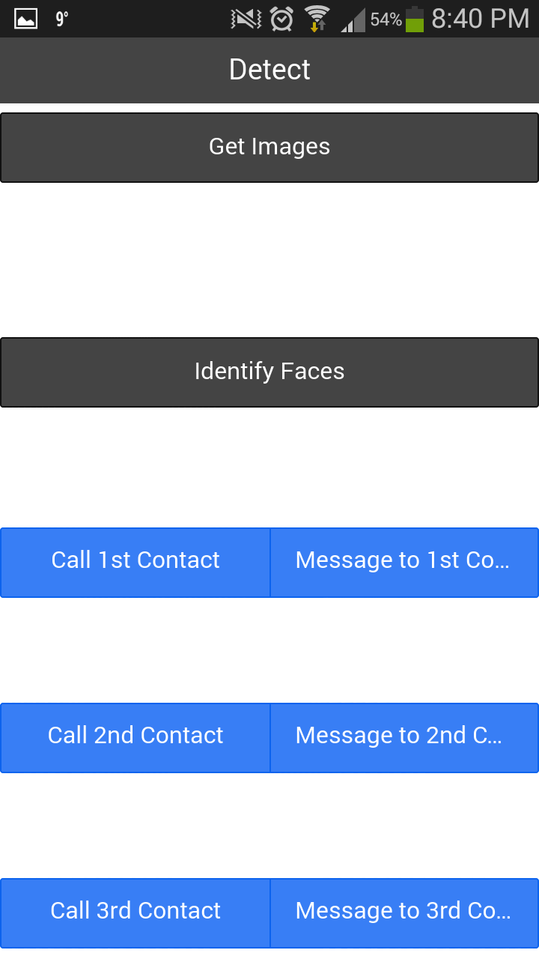

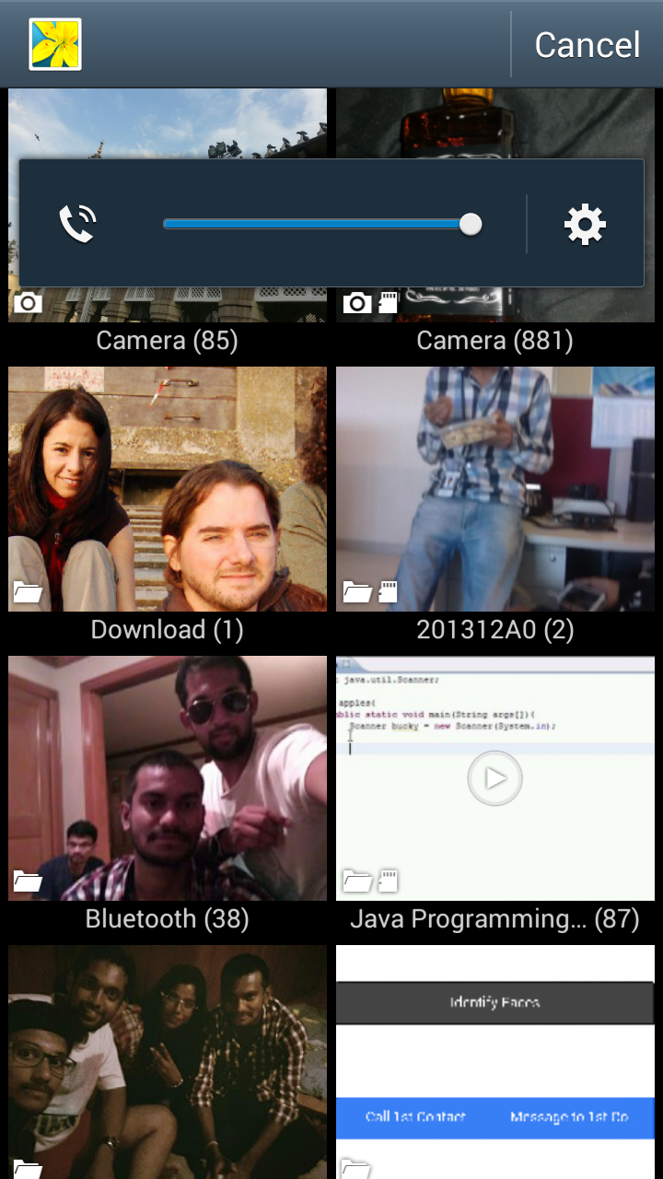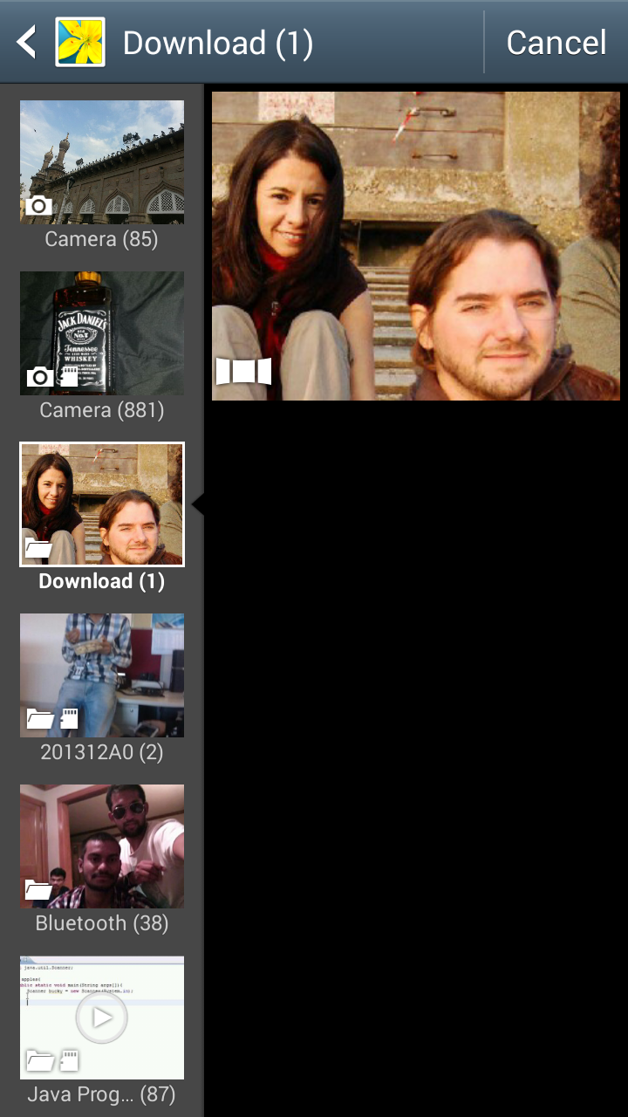

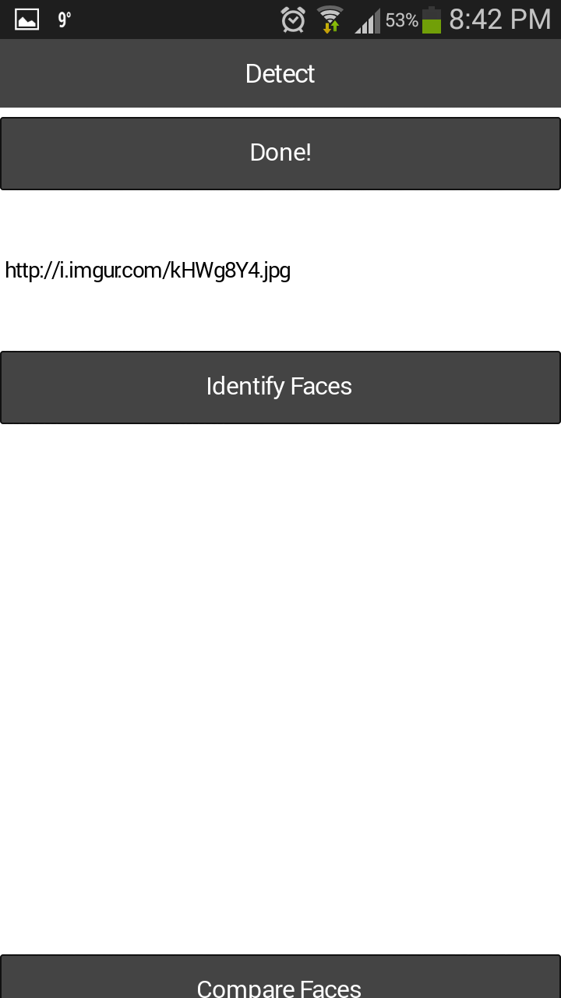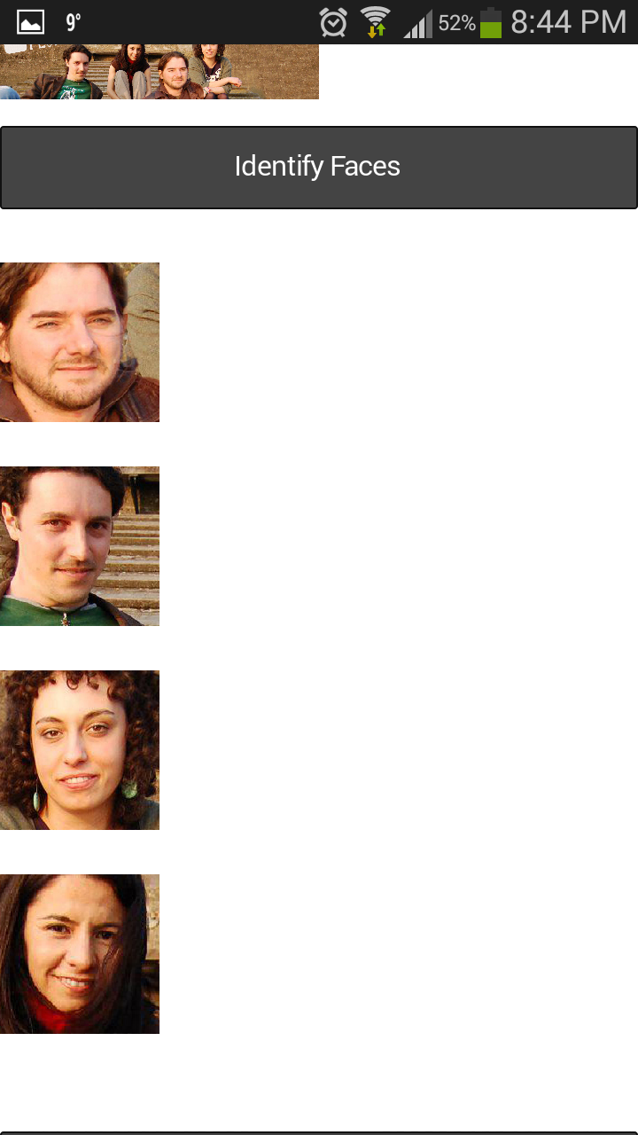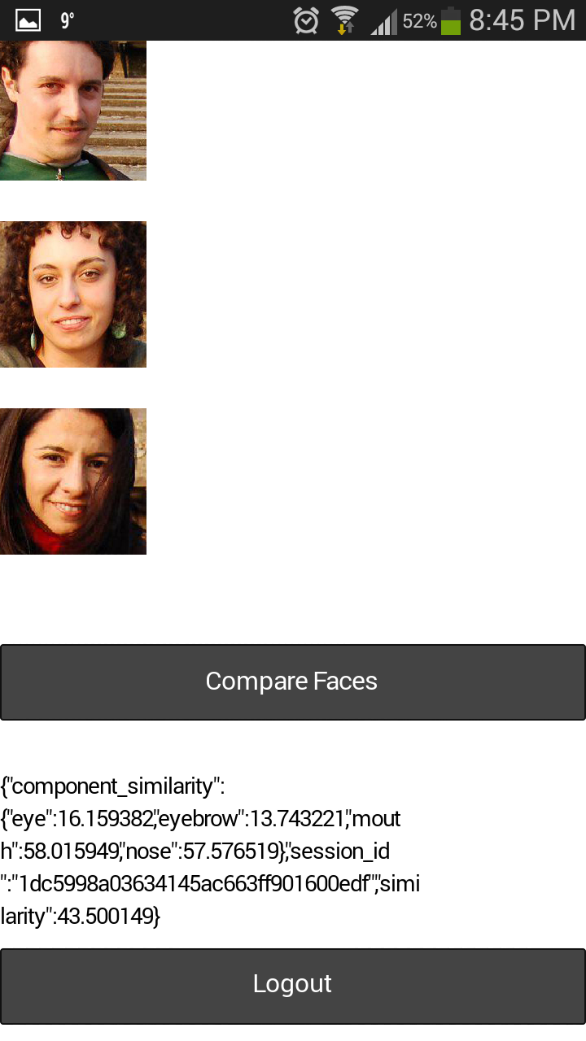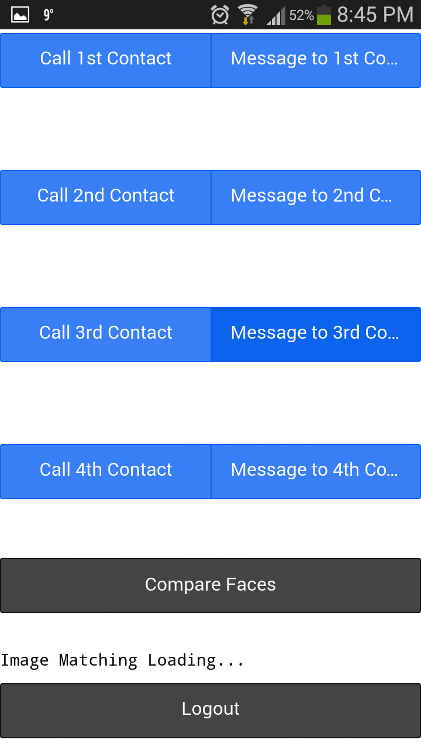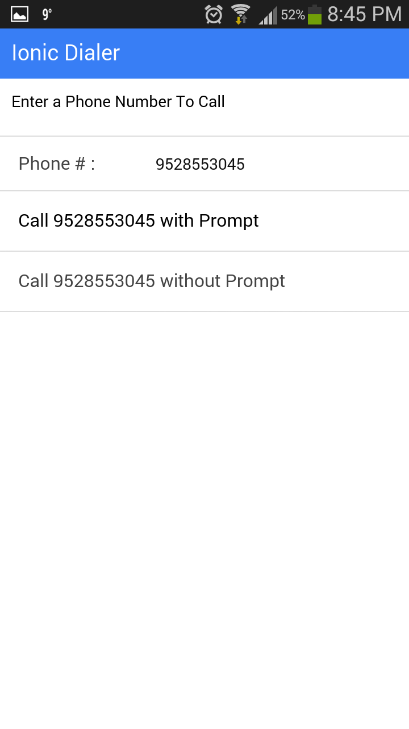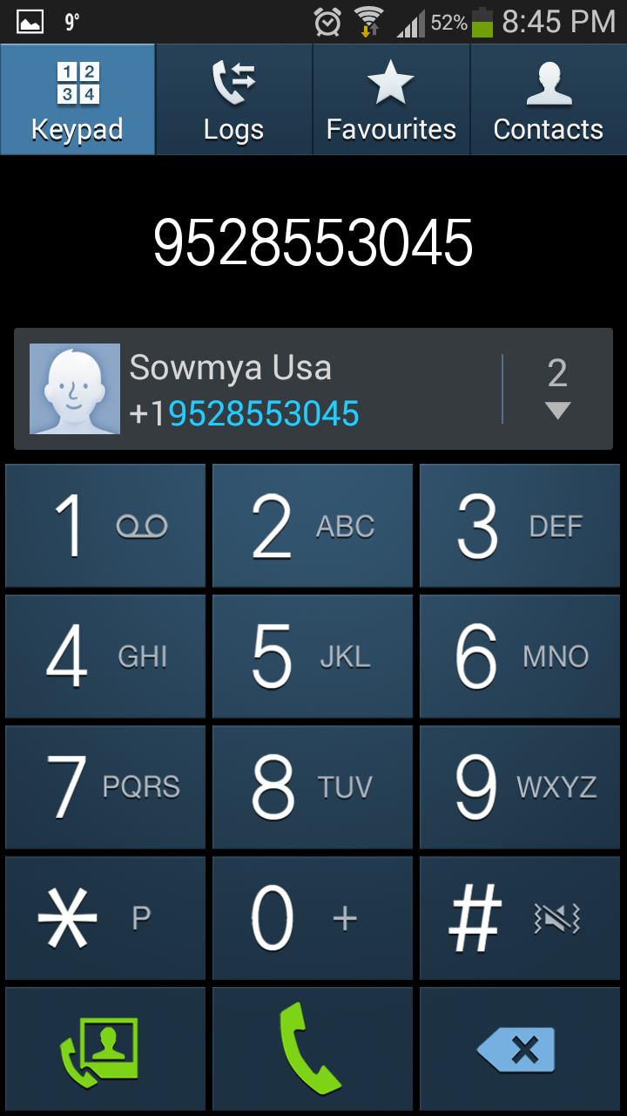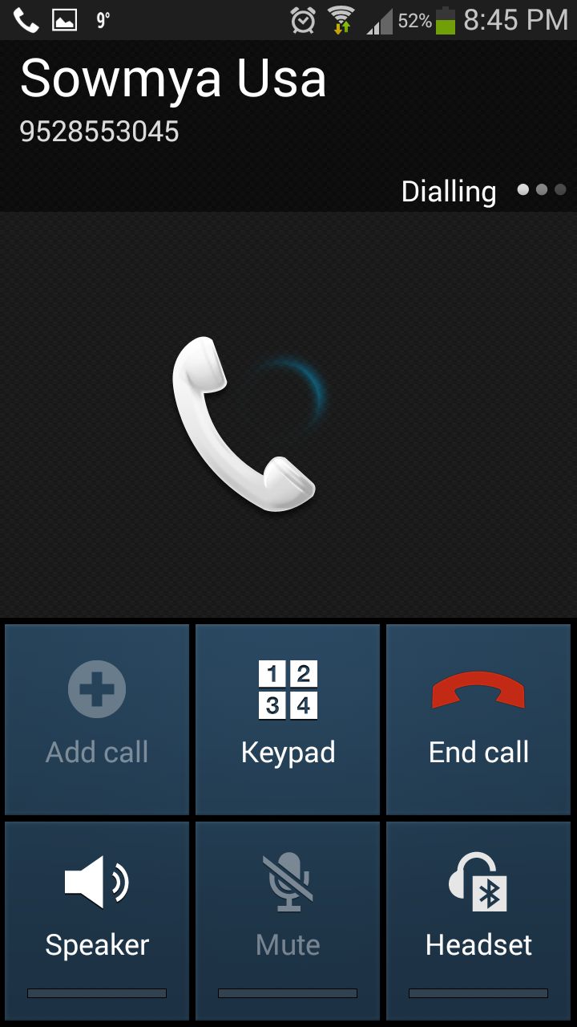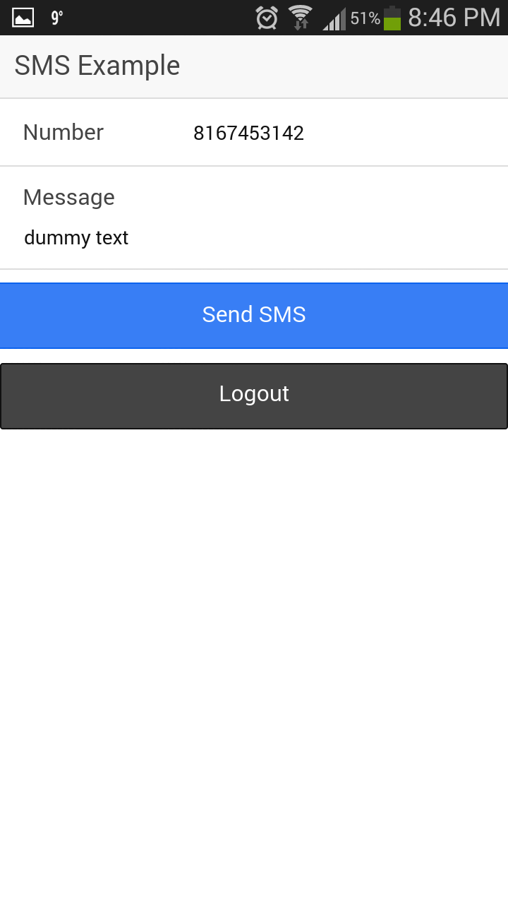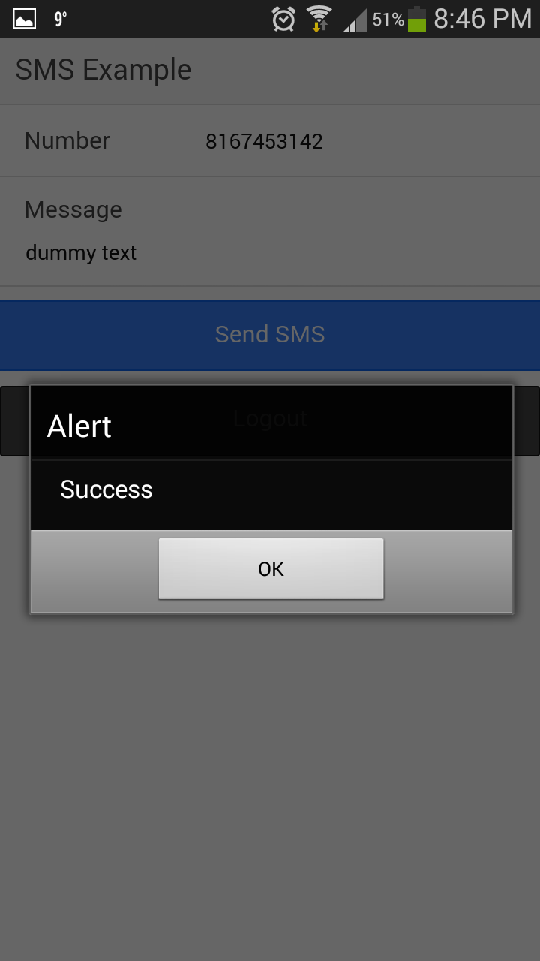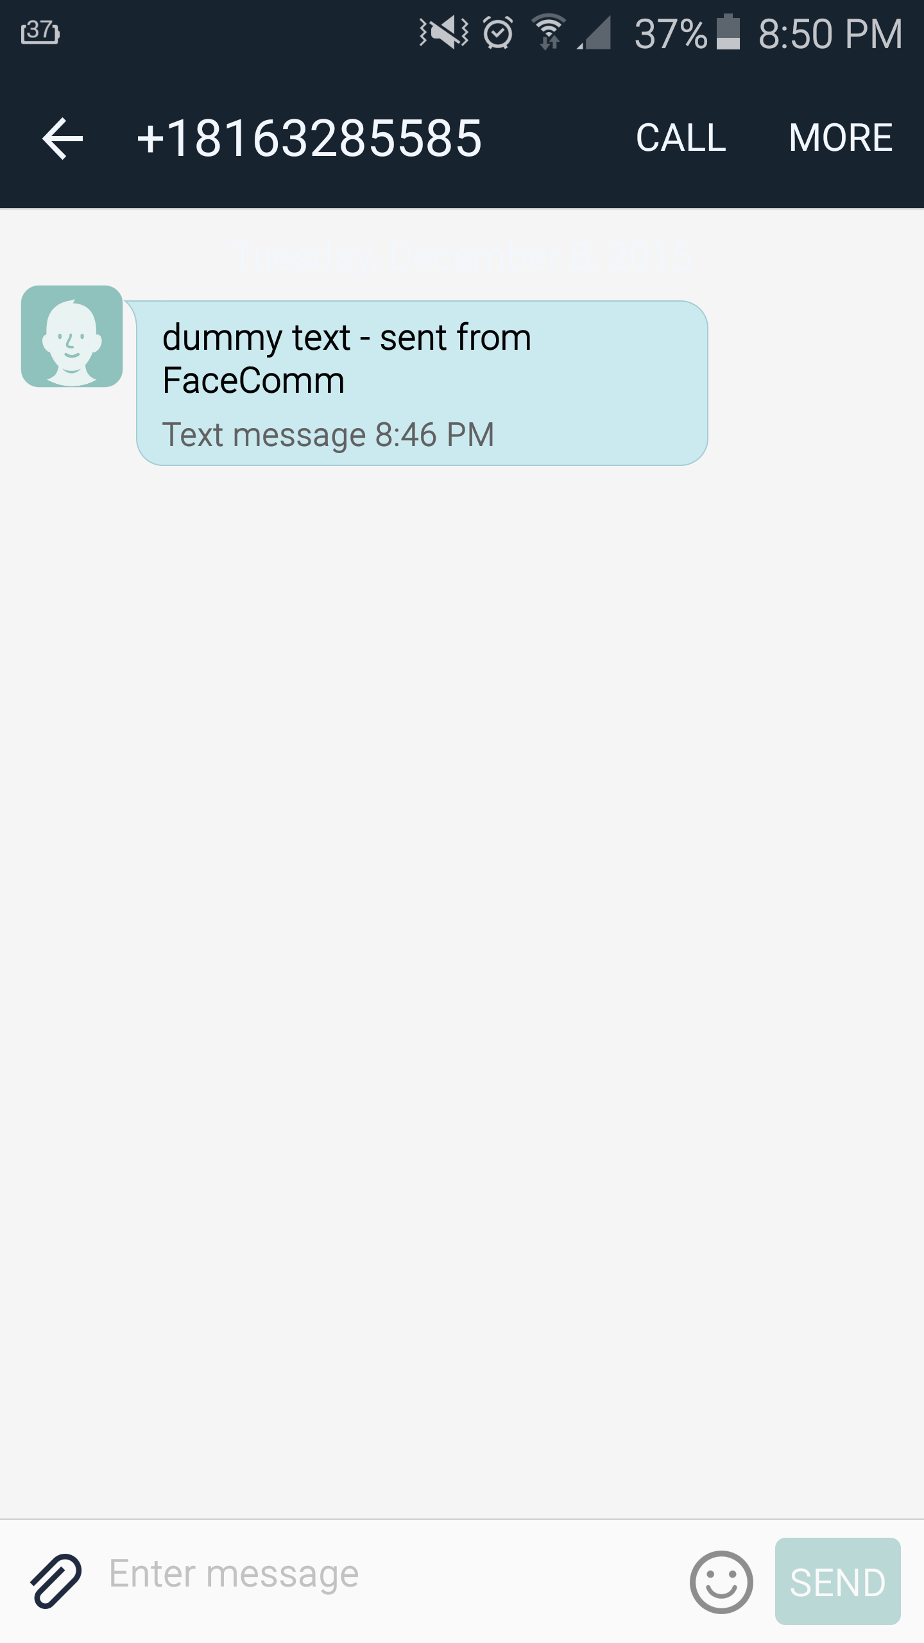

# Performance Testing:

## Tools Used:

### 1) YSlow

### 2) Chrome

### 3) Ionic Framework

### 4) NodeJS IO

## Screenshots:

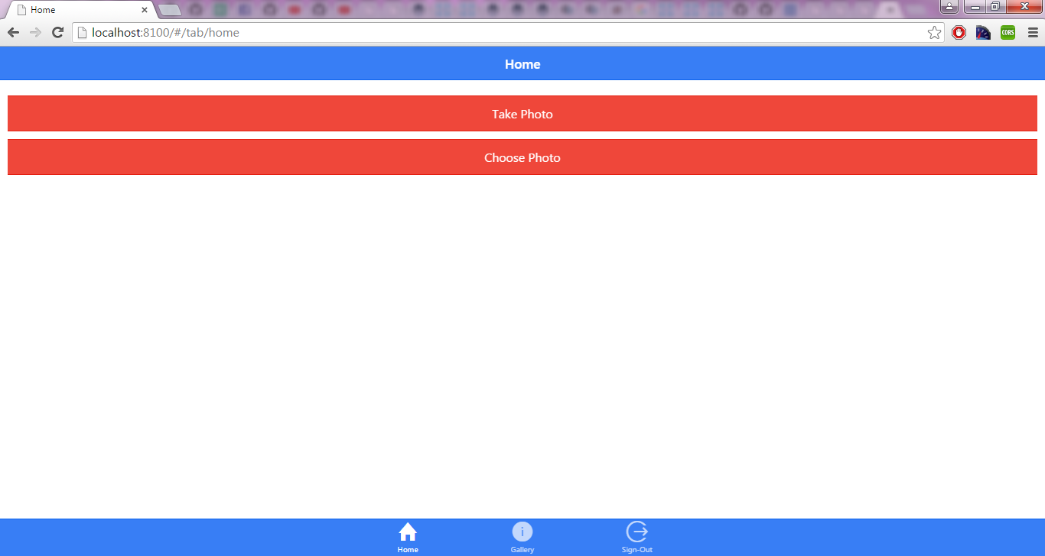 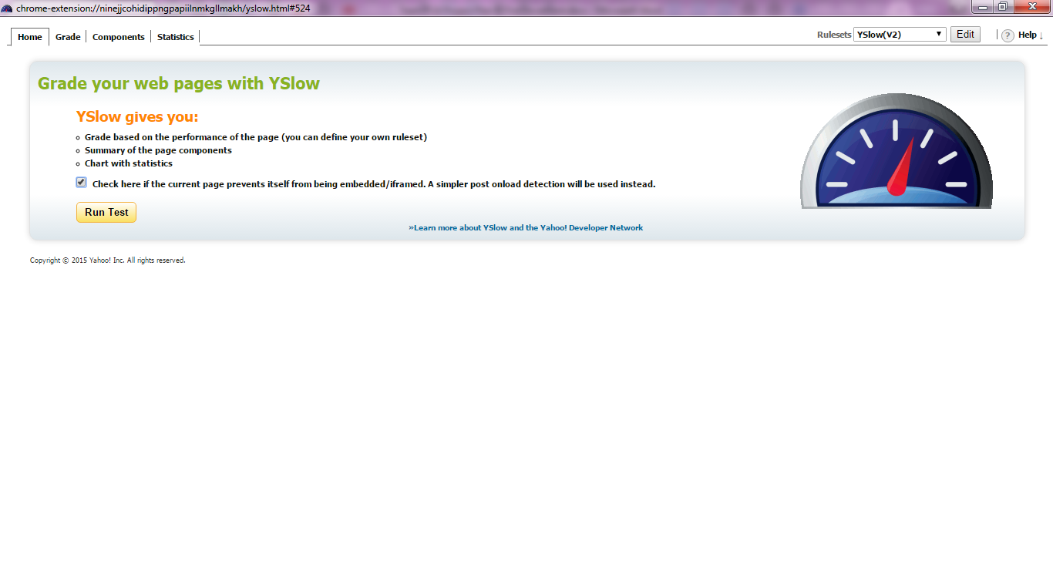 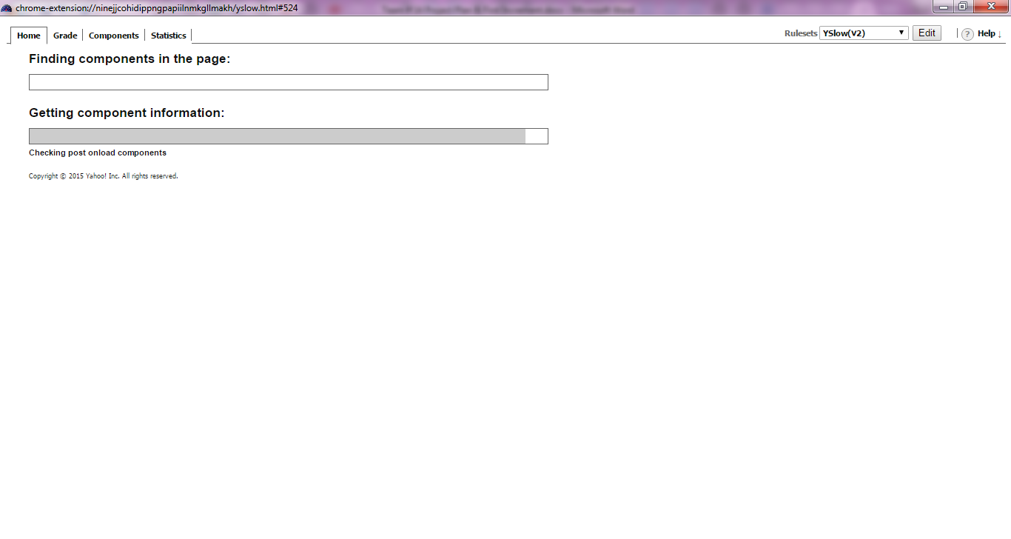 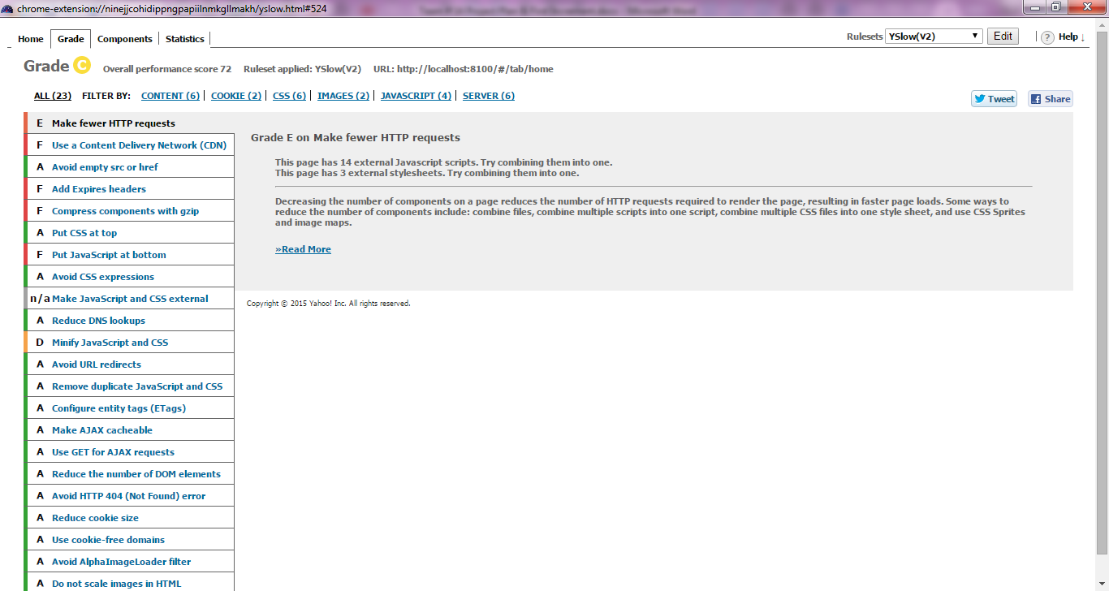 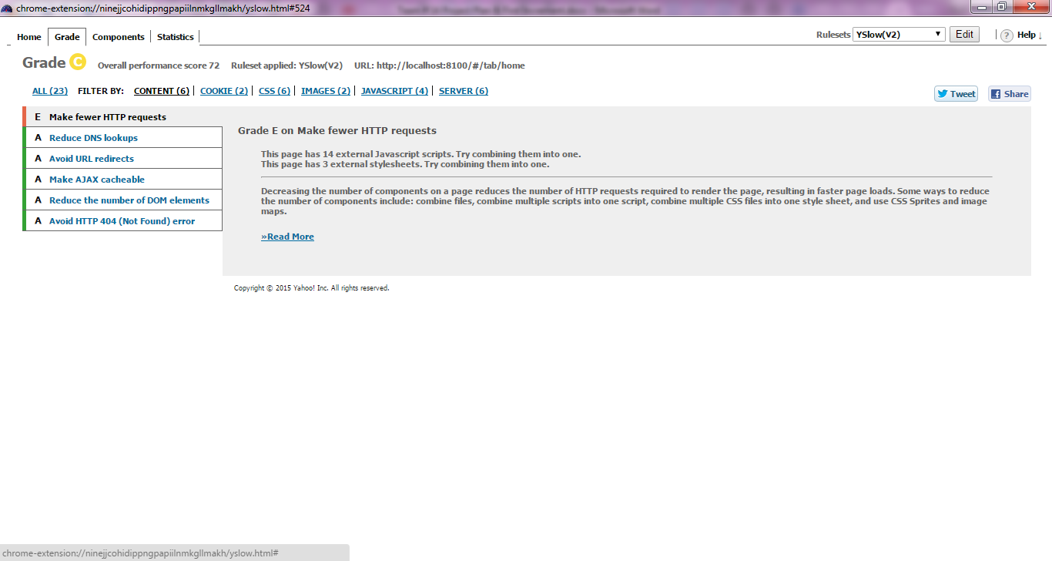 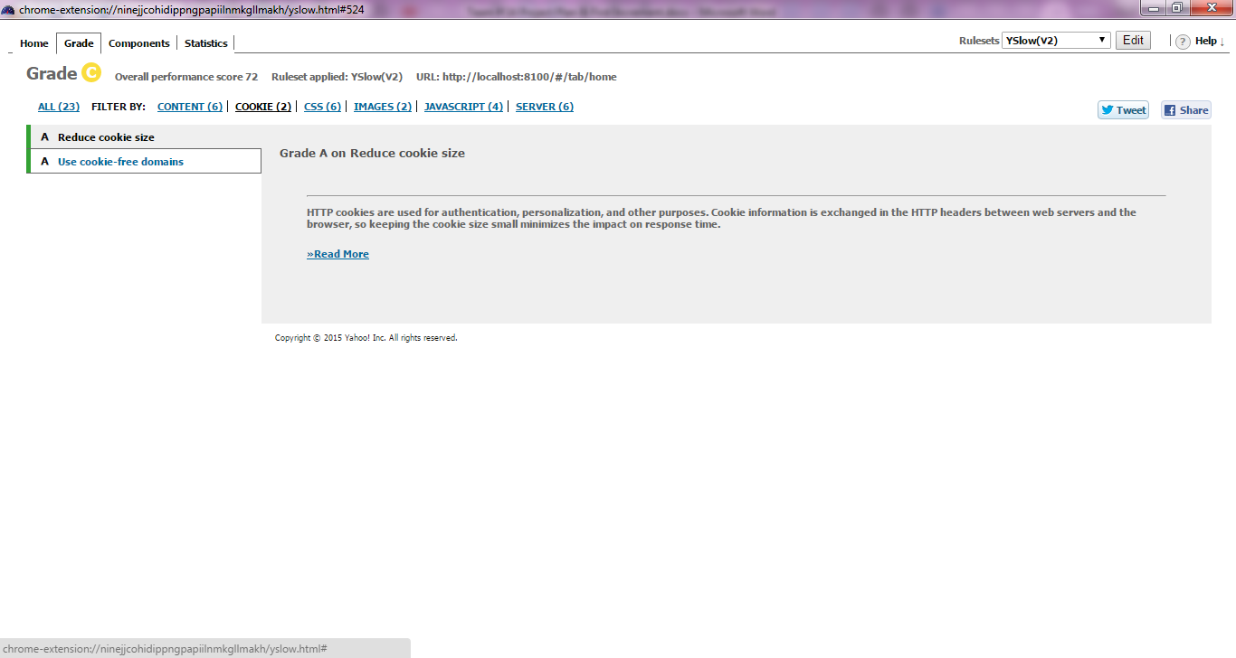 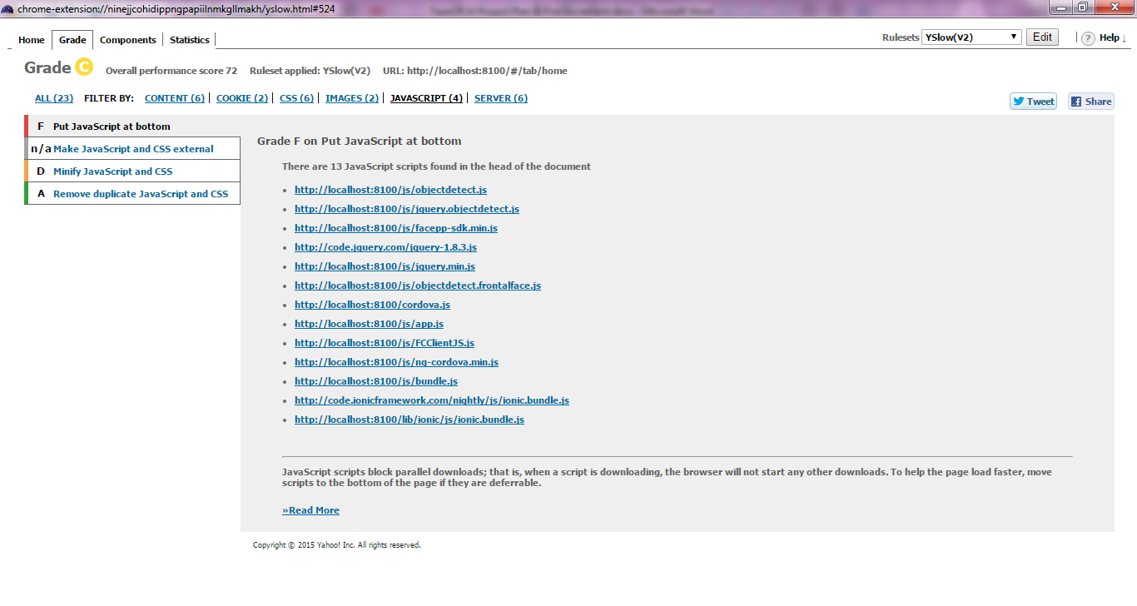 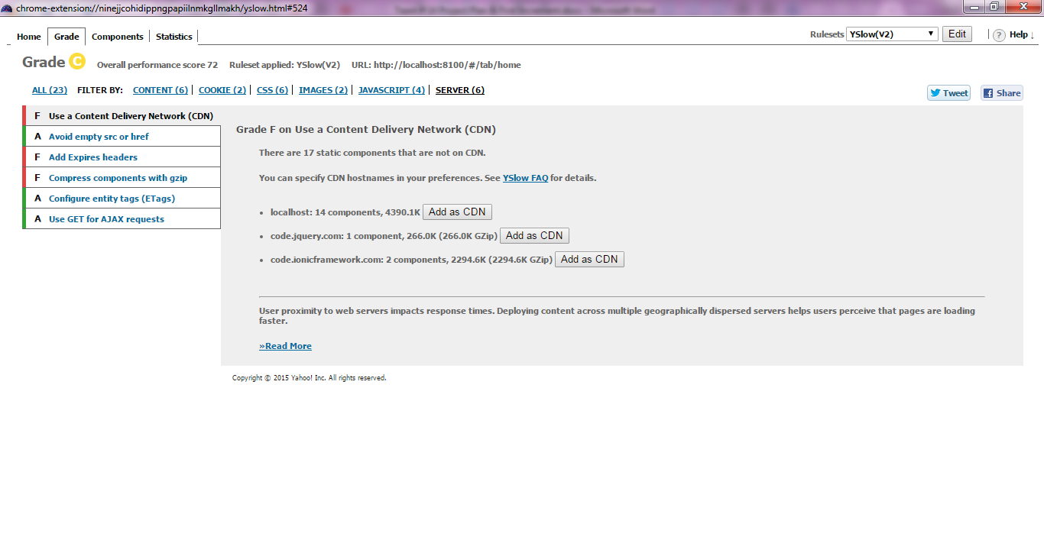 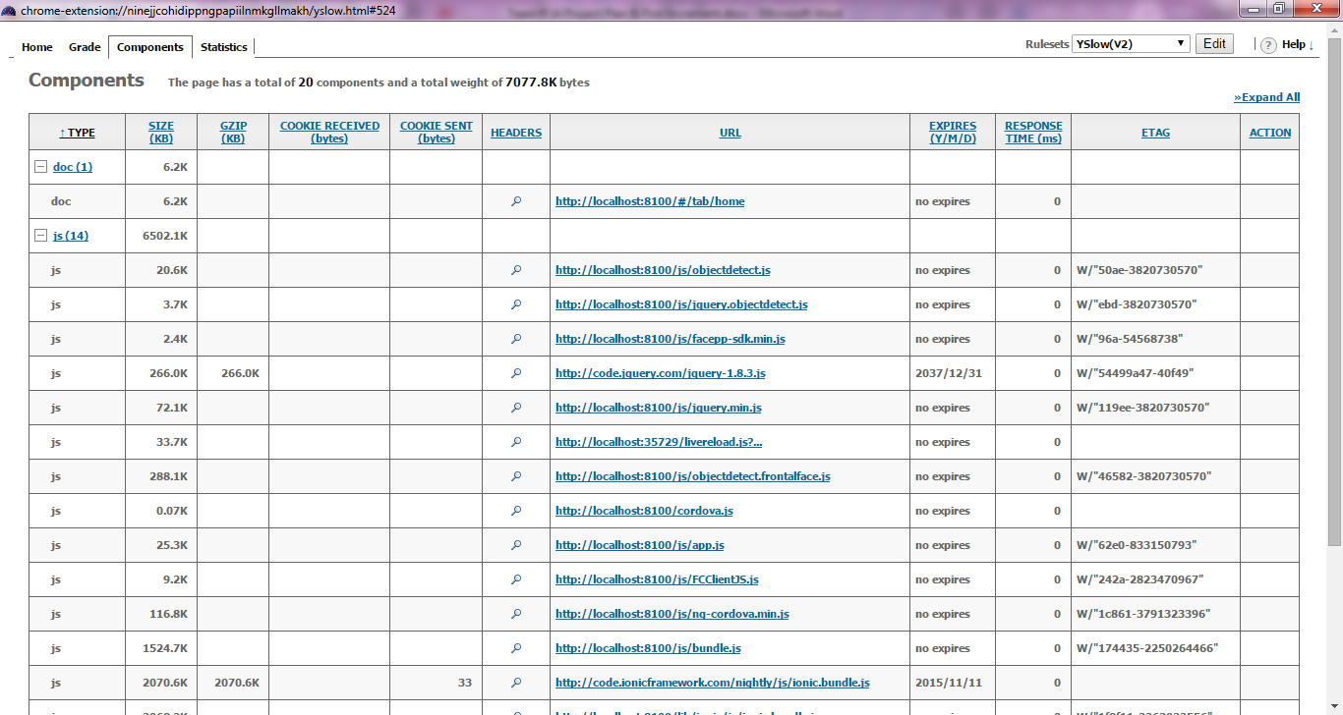 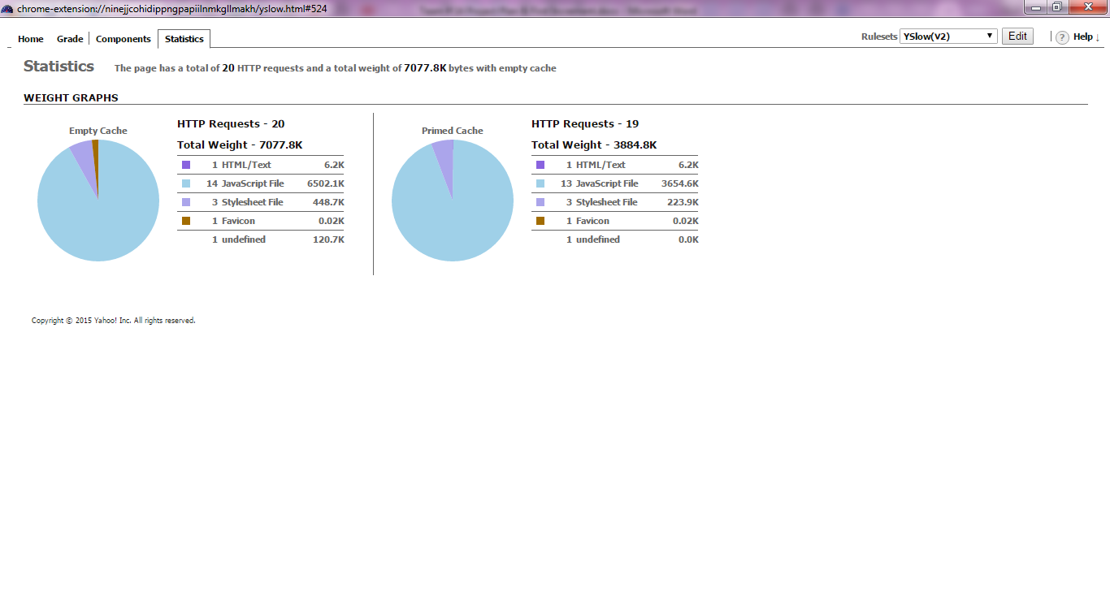

# A/B Testing:

A/B **testing** (also called as split **testing**) is comparing two different versions of a web page for analyzing which web page performs better.

We changed

# Unit Test Cases:

Yet to implement since the JavaScript files are not developed correctly.

### Screenshots:

